

Fall -2018

BIA 660 C – Web Mining

Web Mining of Prescription Drugs Data for Market Study and Analysis

Prof. Rong Liu

Team 5

Gaurav Kshirsagar

Ajinkya Ingle

Priyanka Bhandari

Rohan Waghere

Team 5 Date: 12/07/2018

**Motivation**

The US has the largest pharmaceutical market in the world. If anyone wants to buy a drug, he/she looks for the drug and its possible side-effects in internet. WebMD is the largest website in terms of page views and clicks. It is assumed to be a legitimate source of information. We decided to scrape the data from the website regarding the reviews posted by the patients or caretakers on the website. It will give us a good overview of a particular drug if we get the sentiment analysis and frequently cited side-effects in the reviews. It can also provide valuable information regarding the competitors drugs which are mentioned in the comments.

**Introduction**

The US has the largest pharmaceutical market in the world with a value of $339 billion USD. US prescription drug spending is expected to reach as high as $610 billion by 2021. Pfizer alone spent 7.6 billion dollars on R&D in financial year 2017. The growth is expected to accelerate in coming years. While these drugs are prescribed for their therapeutic properties, their use may result in unintended or adverse effects. There is a need for people to know the quality of drugs in this overcrowded market.

**Project Plan**

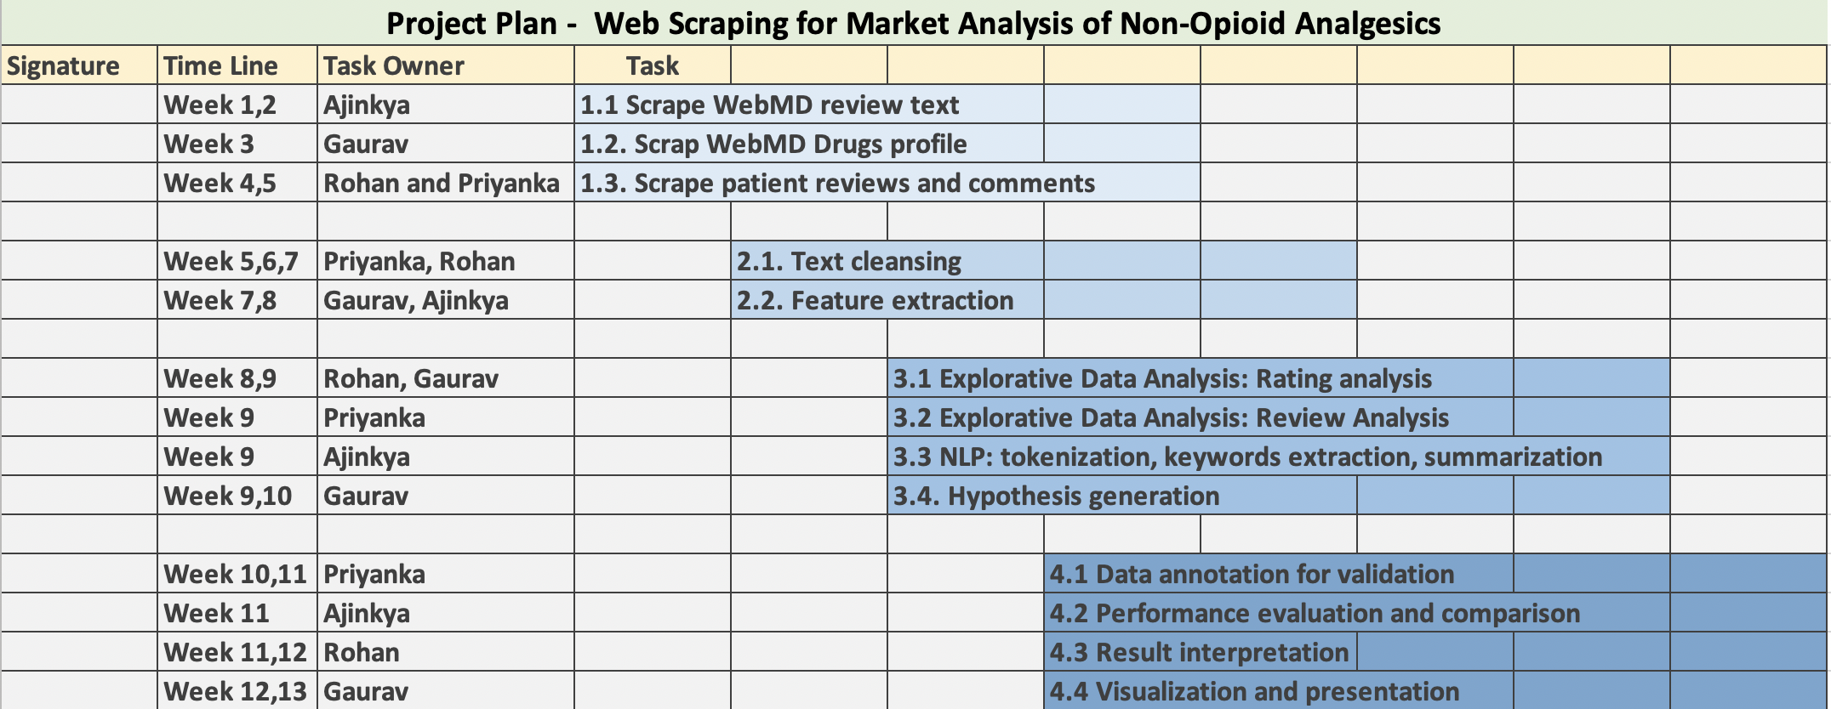

Sheet was edited online and hence is signed digitally.

We started to work according to the above-mentioned plan gathering and cleaning the data. In later stages we were able to get some initial EDA done. At last we were working on classification models and LDA Topic modeling concepts to look for useful insights.

1. **Scrapping the Data**

We first started with going through the WebMD webpages to look for the data we needed. We were looking for some specific category of drugs to be investigated. Finally, we decided to study chronic pain diseases.

Home page of WebMD

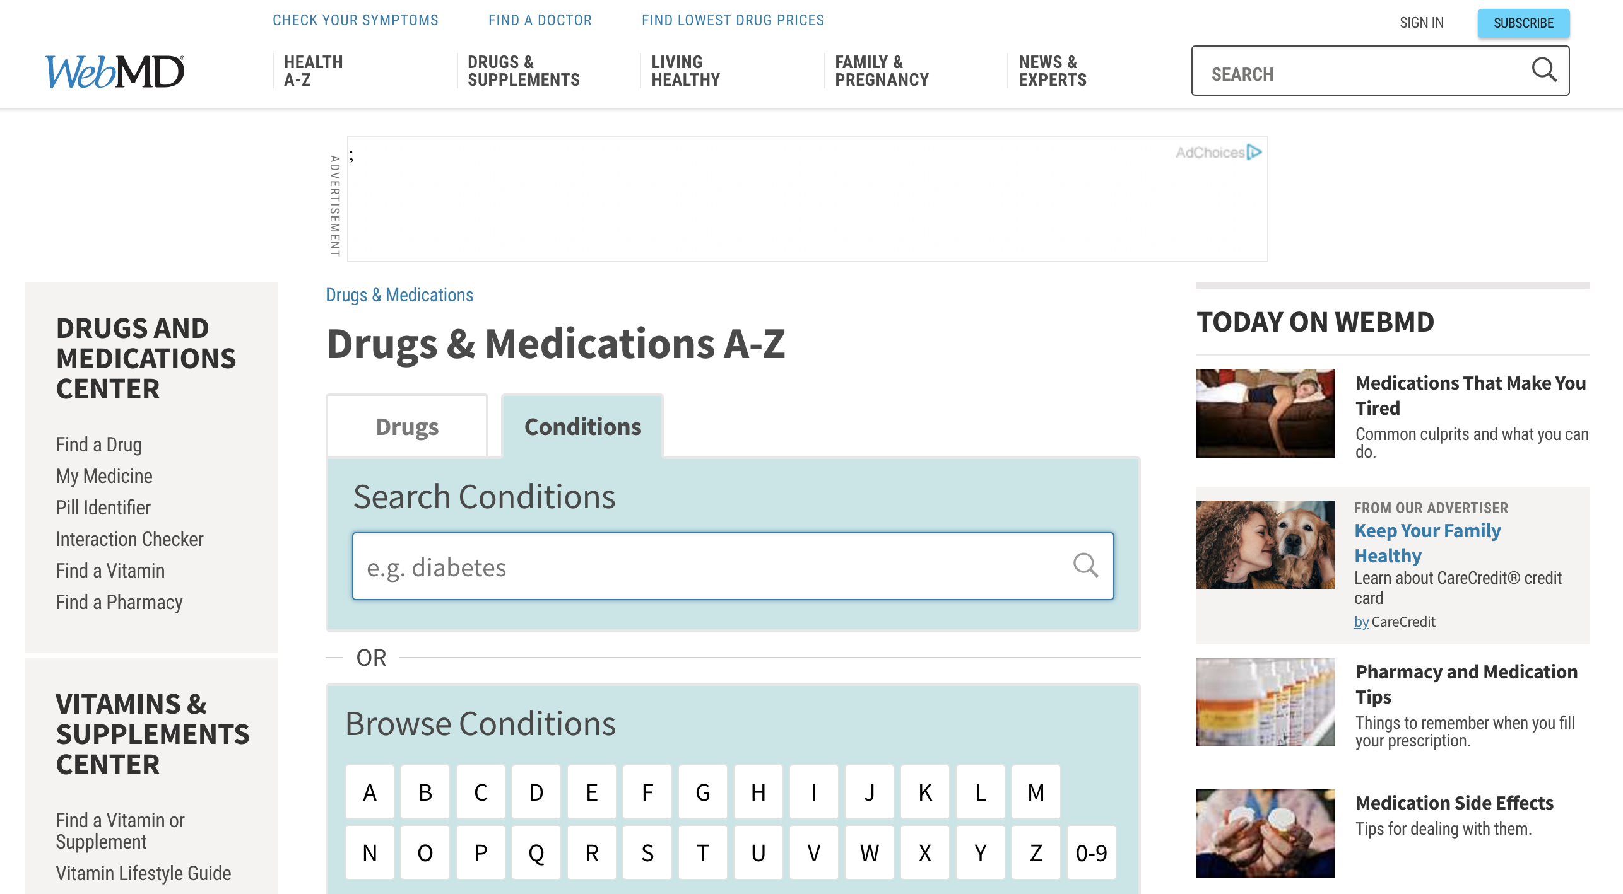

After searching for ‘Chronic Pain’ we got the following results.

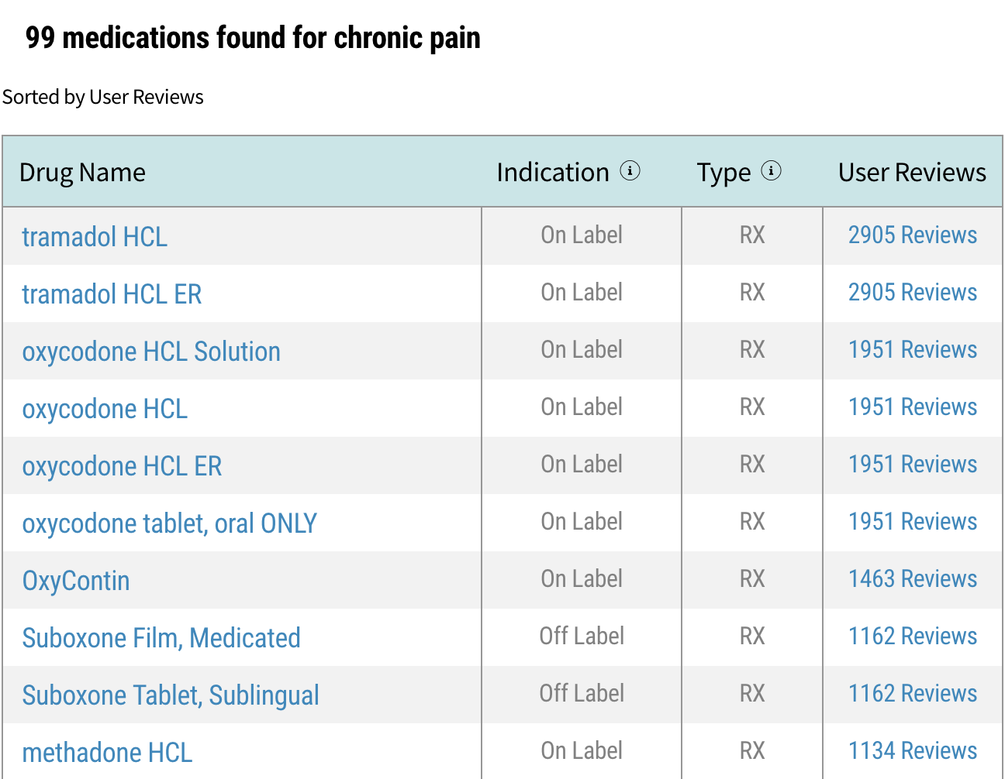

We obtained the top 5 drugs ranked by the number of reviews. And later we collected data from all of them one by one to do a comparative study.

The review format looked like the following picture

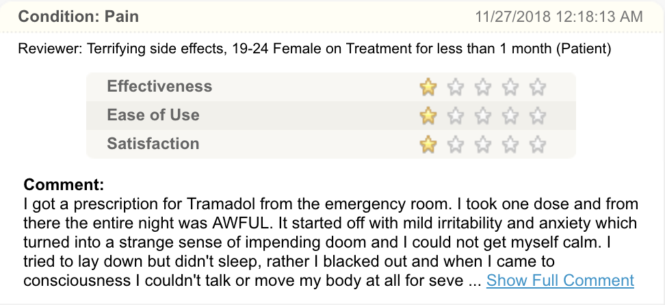

The PHP source code was a below.

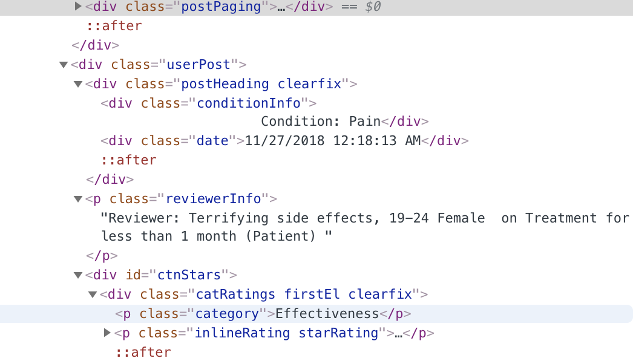

Every page had at max 5 comments. So, we had to go through 200-300 pages to mine all of the 2500-3500 reviews and rating from the website.

1. **Cleaning the data**

The data initially had a lot of noise which needed to be cleaned. We removed any repetitive words from the comments. We also segmented the reviewer information in different column like “age” and “gender”.

Following is the image of raw scrapped data

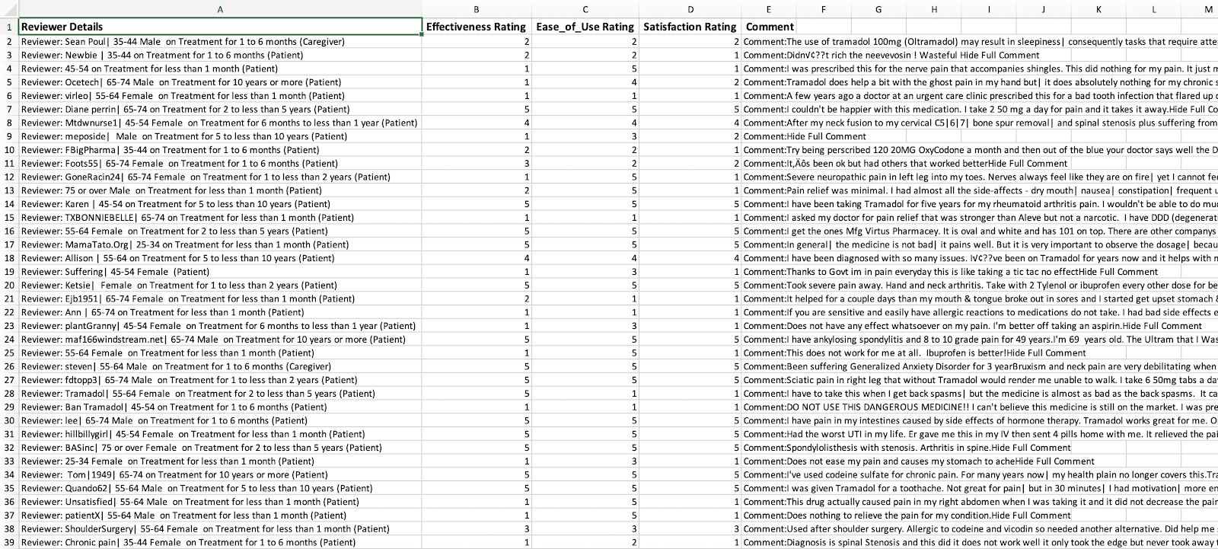

After the preprocessing and cleaning we had this data to work with.

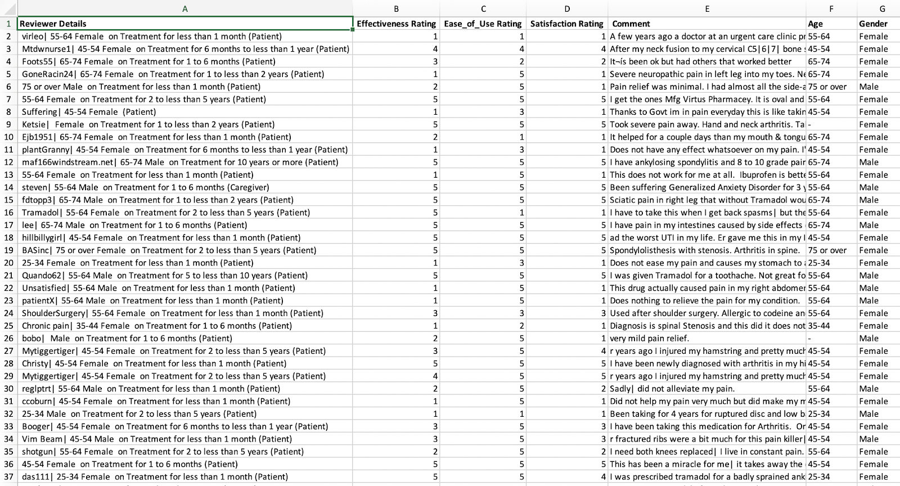

1. **EDA – Exploratory Data Analysis**

In EDA we have observed some really unusual patterns which we have discussed in detail in the following sections. There were variable reactions to this drug in various age groups across males and females.

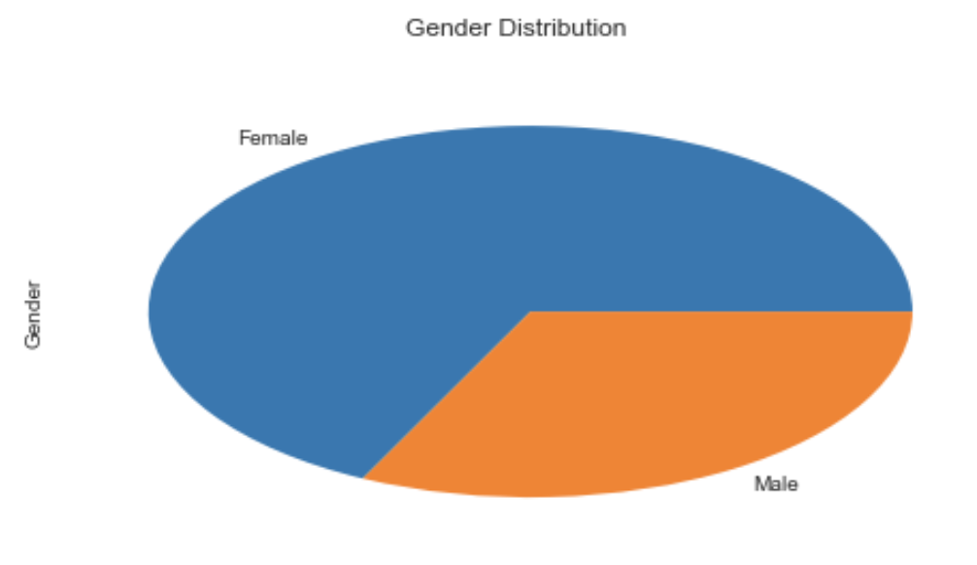***EDA: Gender***

* This graph shows what is the ratio of male to female of the people who gave feedback about the drug.
* The number of female reviewers is very high as compared to the male.
* There are almost 67% Female and nearly 33% Male reviewers.

***EDA: Age***

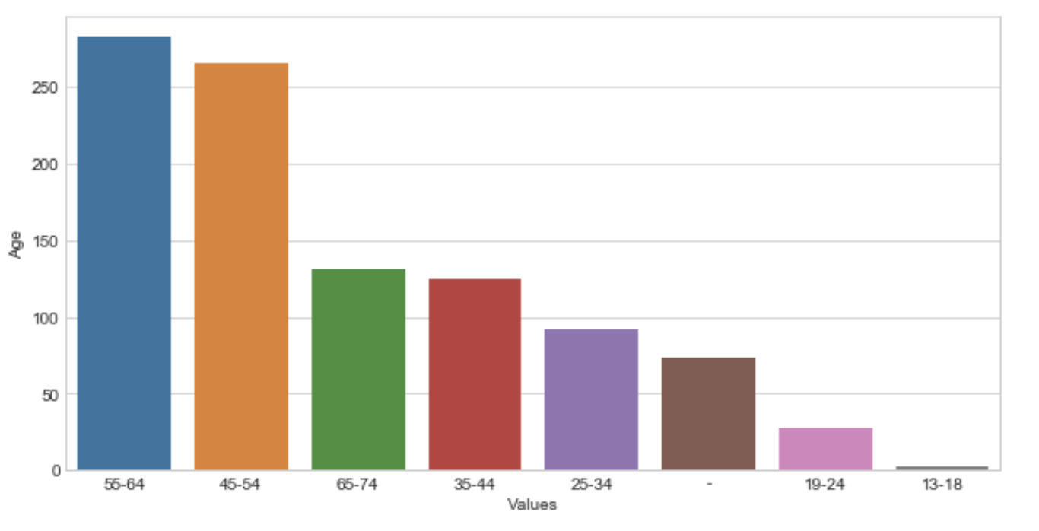

* This graph shows how many reviewers from each Age category have given their reviews.
* The highest number of reviewers are from Age category of ’55-64’
* The Age category of 55-64 and 45-54 cover more than 50% of the reviews.
* 13.1% of analgesics users were above the age group 65

***EDA: Effectiveness Rating***

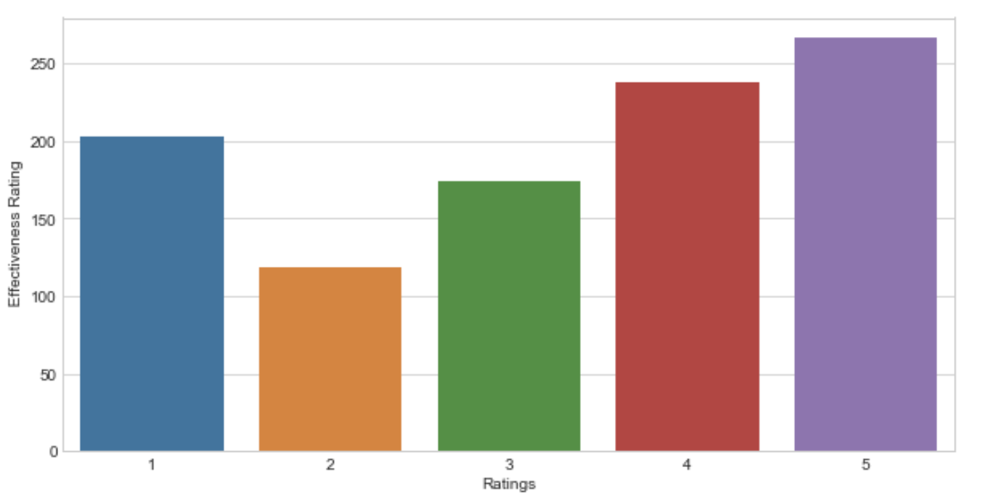

* 26.6% of Analgesics were had the highest Effectiveness Ratings
* More than 50% of the people felt that the drug was effective
* About one fifth of the reviewers didn’t find the drugs effective

***EDA: Satisfaction Ratings***

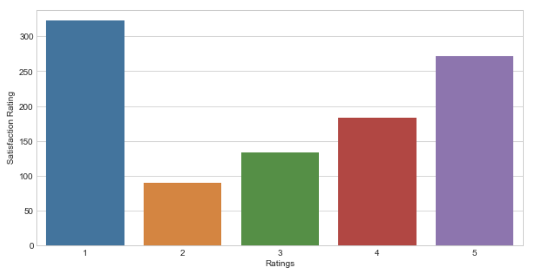

* 32.2% of reviews had the lowest Satisfaction Ratings
* 27.1% of reviews had the Highest Satisfaction Rating
* Most of the people were either completely satisfied by the drug or they found it as completely ineffective.

***EDA: Comparing two or more features***

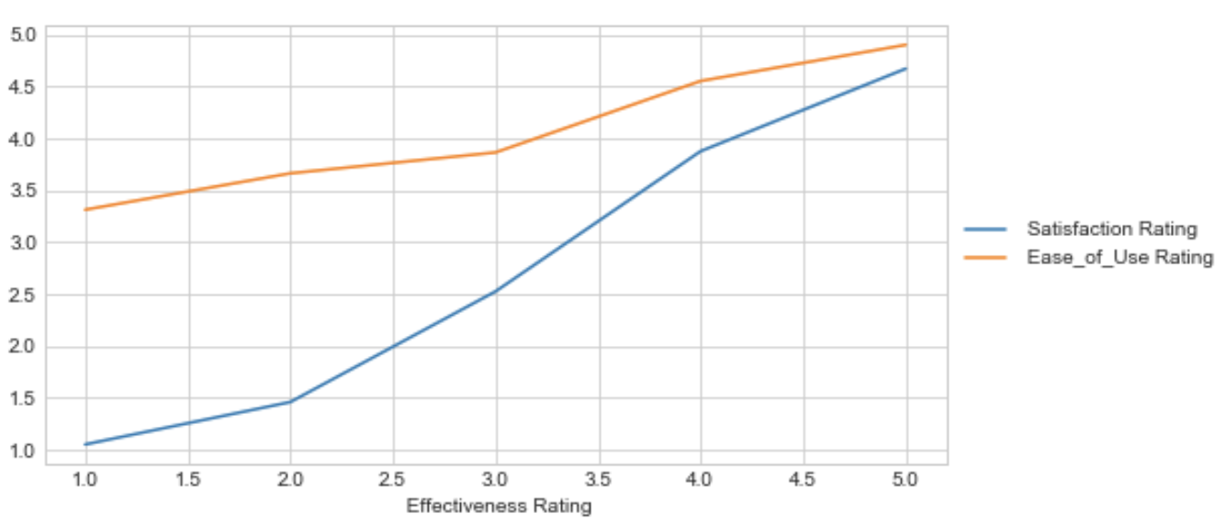

* Satisfaction Rating vs Ease of Use Rating
* Ease of Using the Analgesics doesn’t assure the satisfaction of the customer

***EDA: Comparing two or more features***

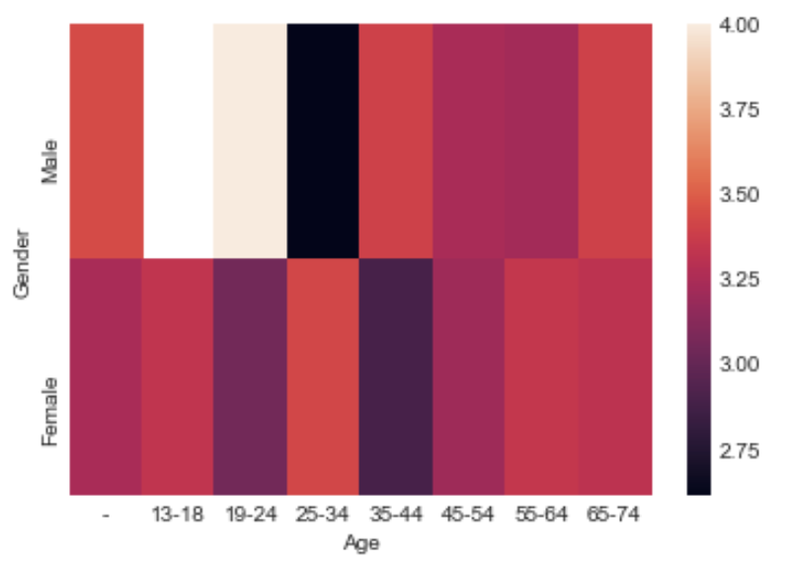

* Comparison of Effectiveness Rating based on Gender of reviewers.
* In the age category of 19-24 we can see that the Males found the drugs effective whereas the Females didn’t.
* Similarly, in the age category of 25-34 Females found the drug effective but the Males didn’t.

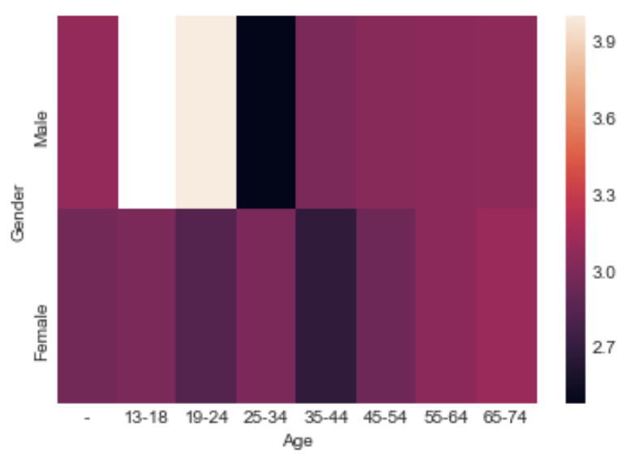

* Comparison of Satisfaction Rating based on Gender of reviewers.
* Here also we can see the variation in the Effectiveness rating, which changes according to the Gender and the Age category.

1. **NLP and Reviews analysis**

It was observed that most of the reviews in our sample dataset were rated 1,4 or 5

Also, the length of most of the review never exceeded 50 words.

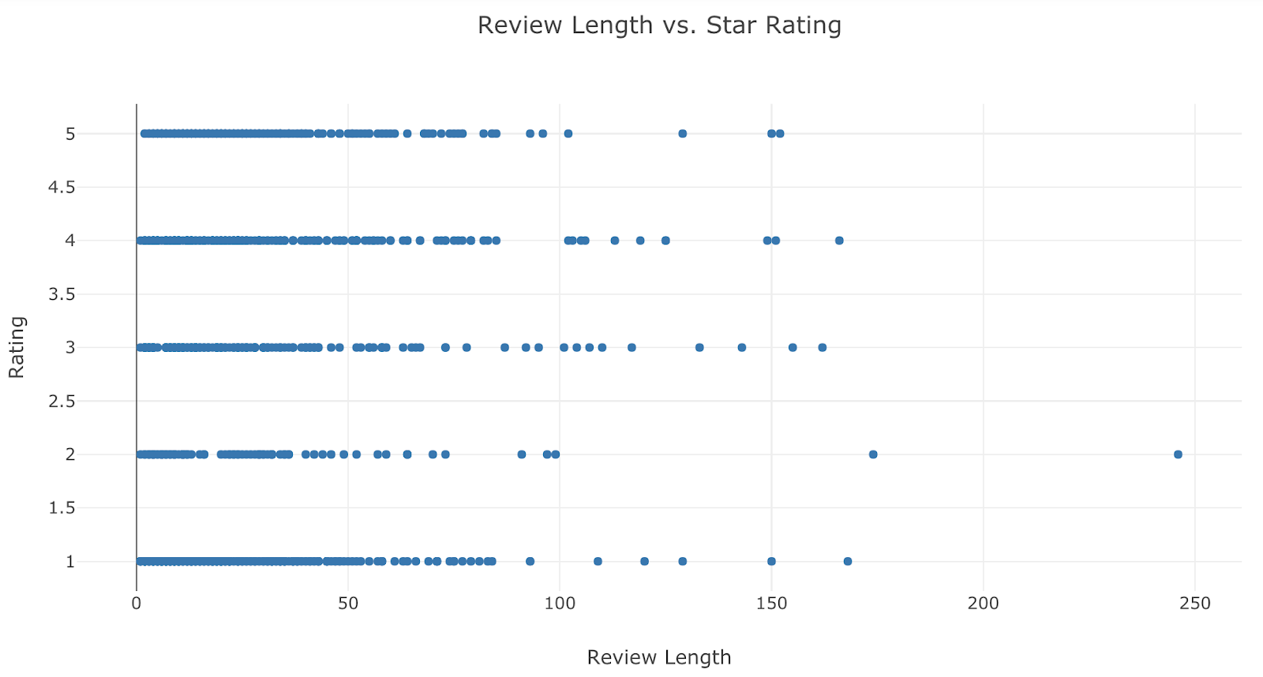

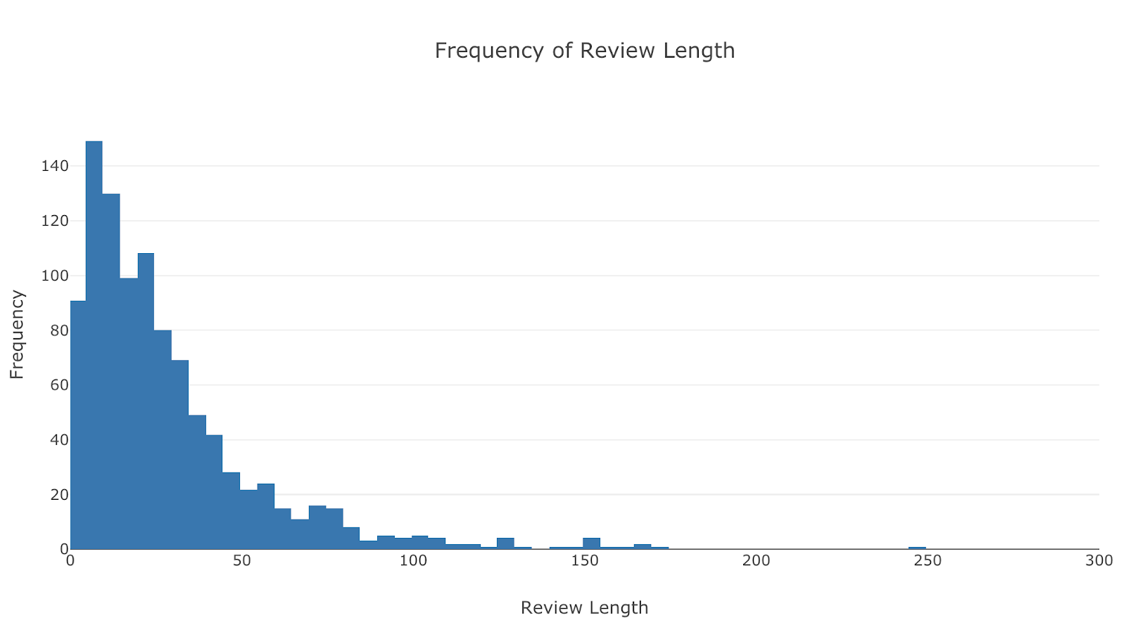

We also calculated the review length to rating **correlation** to be **0.068**

Using tfidf vectors we determined the top 5 words by their weight, occurring in every comment. This gave us a brief idea of what people were taking about in the comments.

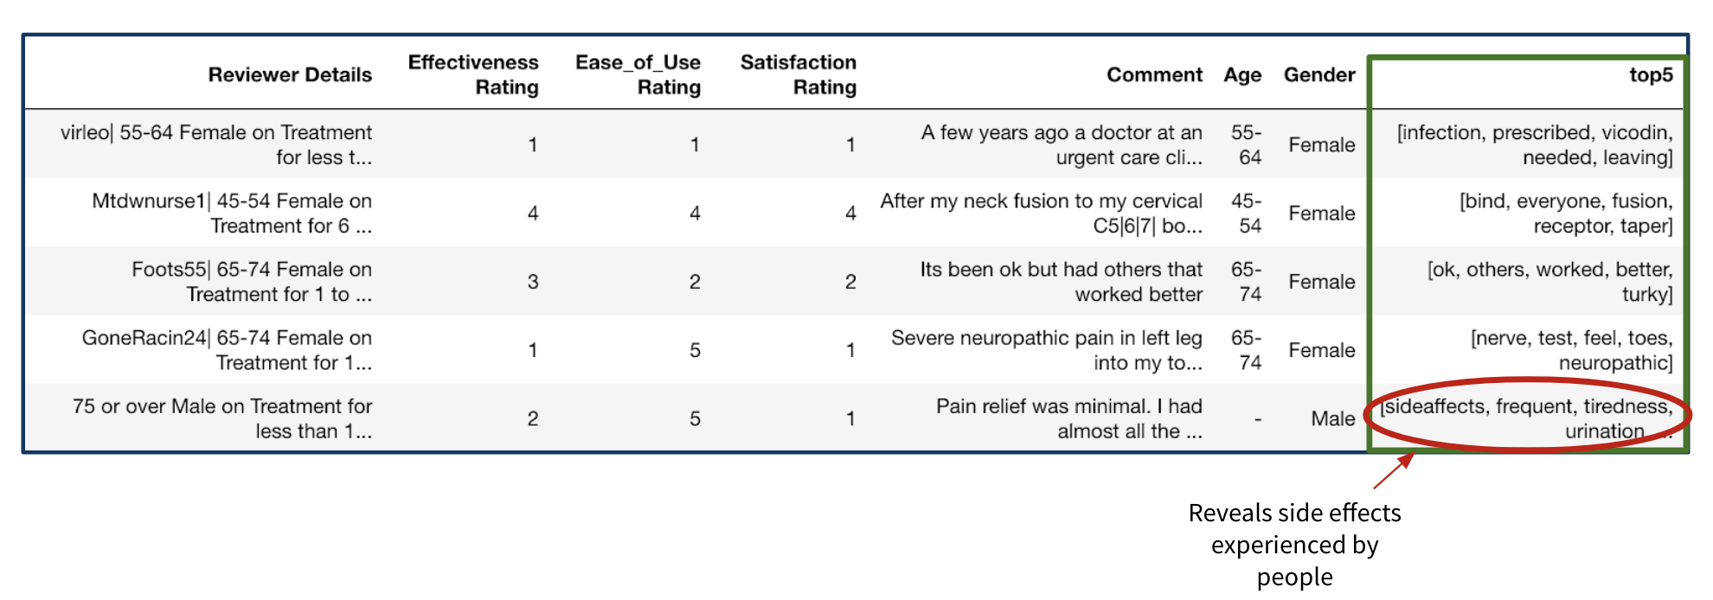

We were also able to spot some side effects in these extracted top5 words by tfidf weight.

Wordclouds made it easier to spot the keywords we were looking for.

***Wordcloud for Male patients***

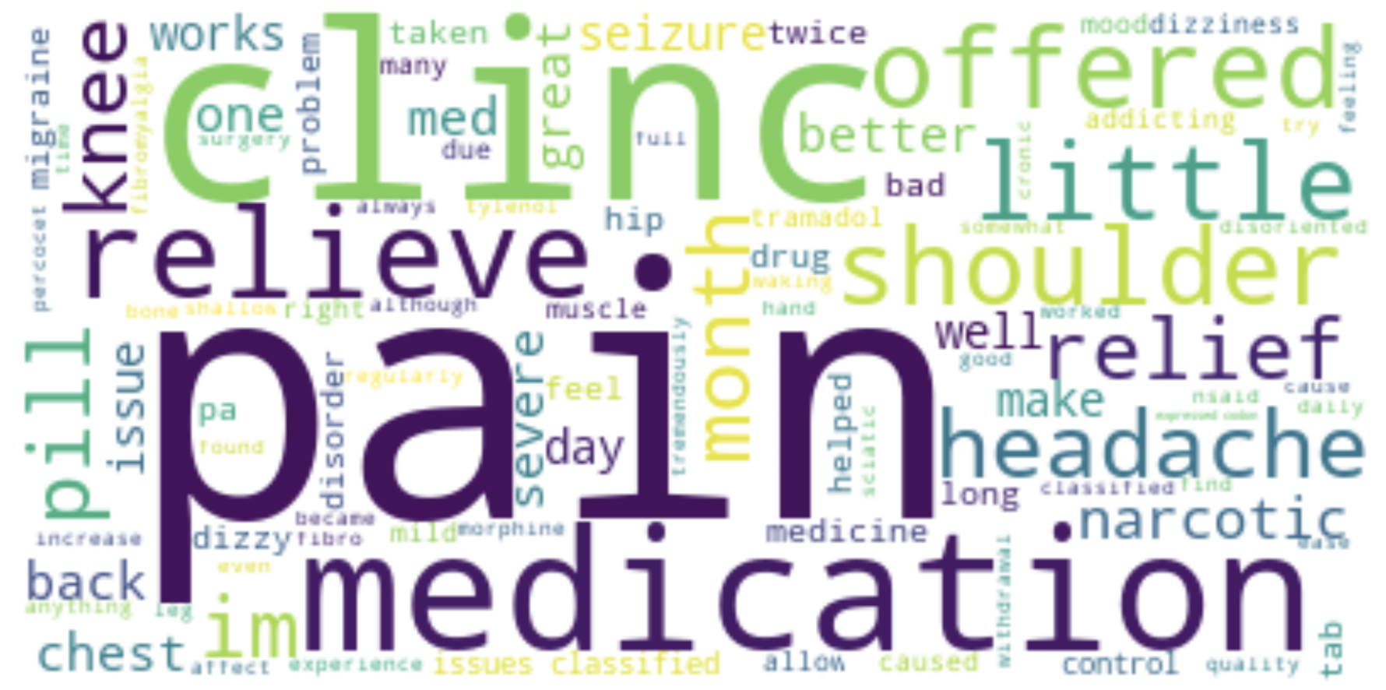

***Wordcloud for Female patients***

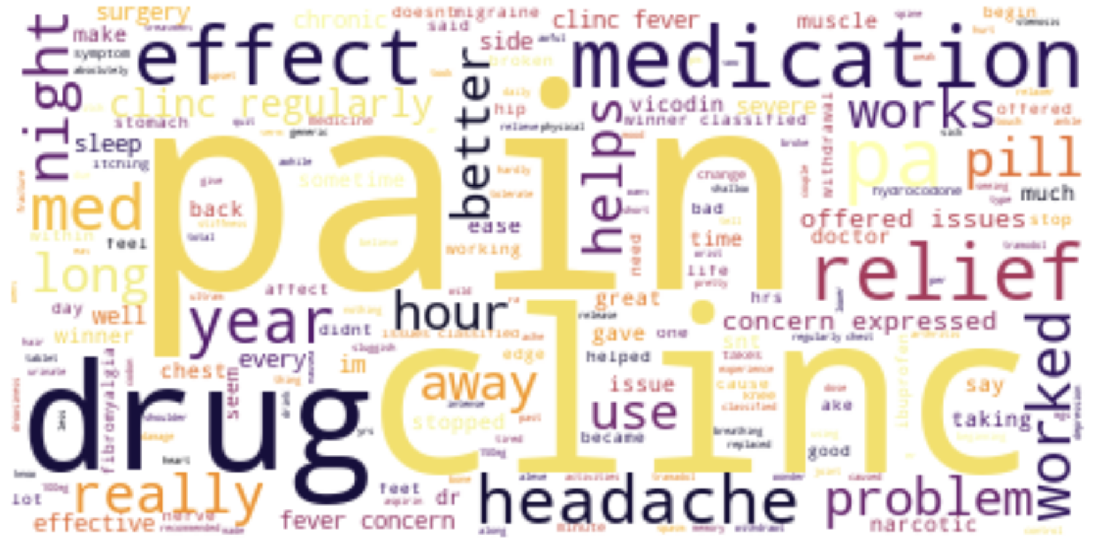

1. **Classification**

We used 2 approaches to classification.

1. Extract Features from the comments and use these features as input parameters to classify the satisfaction rating.
2. Tokenize the comments, generate tfidf vectors and then classify satisfaction ratings based on the on these vectors.

***First Approach***

We used 3 buckets of comments for an extended study of classification. We used:

* Comments
* Cleaned Comments and
* Adjectives from the comments

Results

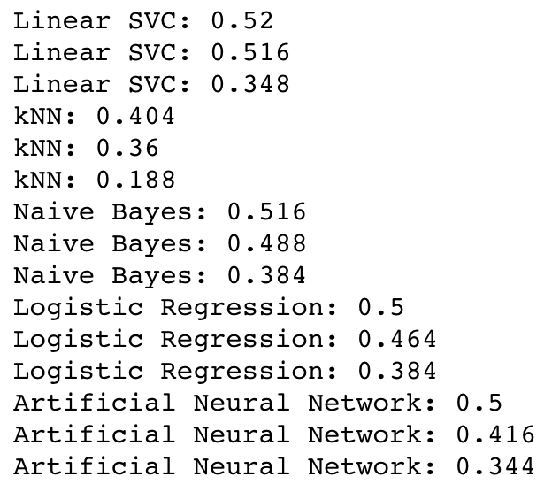

***Second Approach***

We are using following steps to perform classification.

* Download the data in csv format
* Adding number of words, punctuations, unique words, stop words.
* Introducing polarity and subjectivity with the help of Text Blob and to see if performance can be improved.
* Run various models including Naive Bayes, KNN, Neural Networks, Random Forest, Logistic Regression, SVM.
* Calculate their accuracies and compute confusion matrix for each and then compare.
* Then we perform parameter tuning on Neural Network algorithm which yields us 50 % total precision.

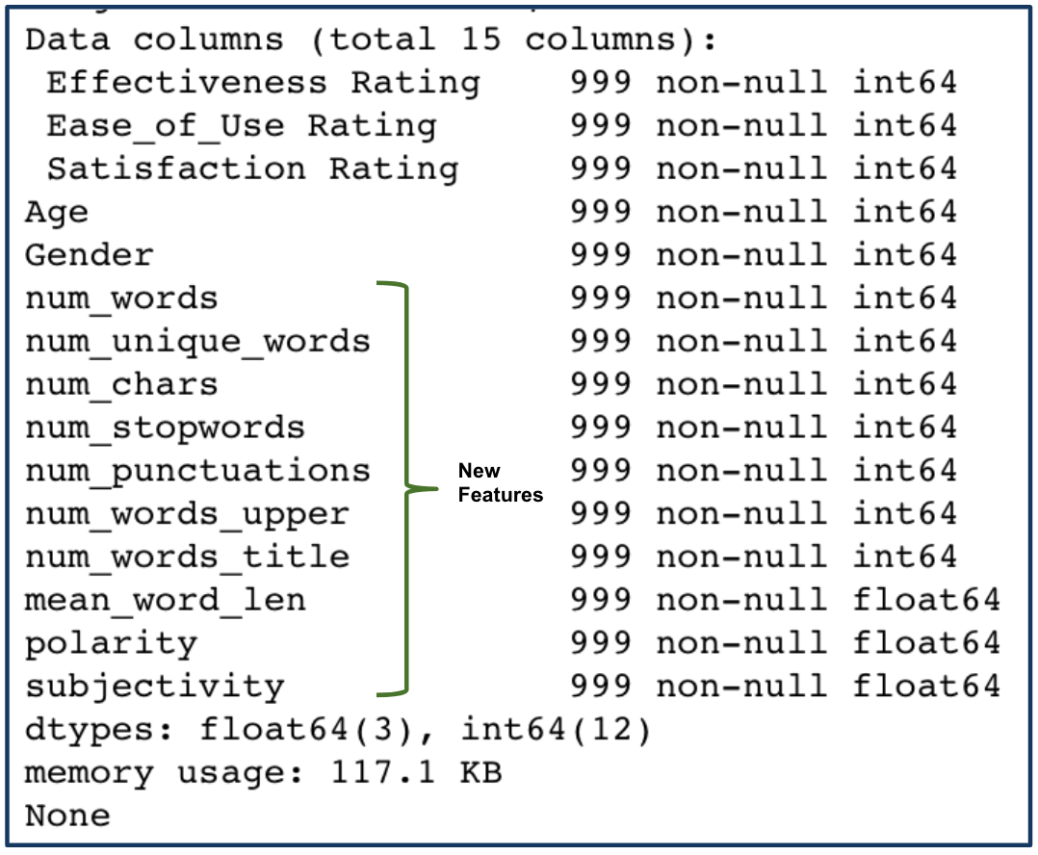

**Naïve Bayes**:

* This text-based classification algorithm assumes that words in a document are independent hence the performance achieved was not appropriate as it does not model the text well
* Satisfaction rating was predicted with respect to other numeric columns in the dataset. After fitting the algorithm, we achieved model accuracy of 59%.
* In confusion matrix, the diagonal items represent true-positive values whereas everything else either represents true-negative or false-positive values. This corresponds to error of 41%.

**Parameters and confusion matrix**

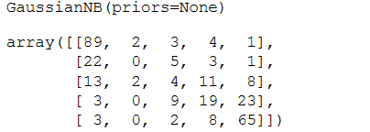

**Logistic Regression Algorithm**:

* We have taken 100 iterations to achieve appropriate accuracy and to make the model optimize our performance since our dataset was not really big , thus this algorithm couldn’t prove to be that significant for our use.
* We achieved model accuracy of 60.6%.
* In confusion matrix, the diagonal items represent true-positive values whereas everything else either represents true-negative or false-positive values. This corresponds to error of 39.4%.

**Parameters and confusion matrix**

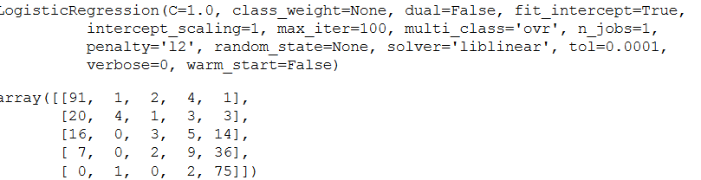

**Support Vector Machine Classifier Algorithm**:

* Satisfaction rating was to be predicted with respect to other numeric columns in the dataset. After fitting the algorithm, we achieved model accuracy of 43%.
* In confusion matrix, the diagonal items represent true-positive values whereas everything else either represents true-negative or false-positive values. This corresponds to error of 57%.

**Parameters and confusion matrix**

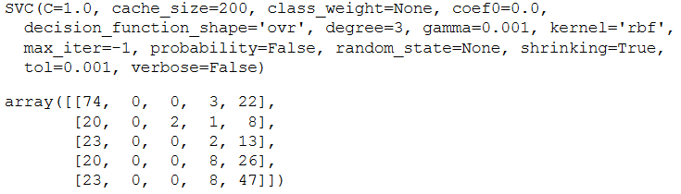

**Random Forest Algorithm:**

* It’s a very popular classifier used to fit the model as it helps to combine multiple models ie multiple decision trees to achieve the results
* Satisfaction rating was predicted with respect to other numeric columns in the dataset. After fitting the algorithm, we achieved model accuracy of 61.6%. It proved to be a good predictor variable for our case.
* In confusion matrix, the diagonal items represent true-positive values whereas everything else either represents true-negative or false-positive values. This corresponds to error of 38.4%.

**Parameters and confusion matrix**

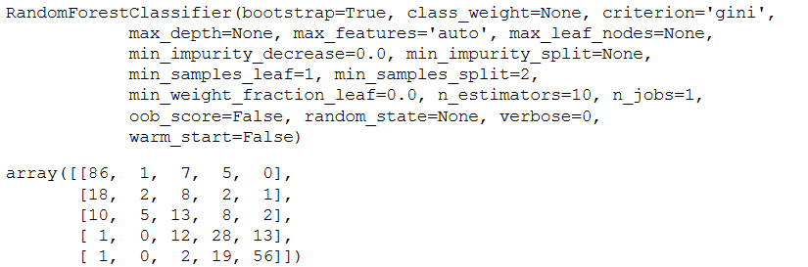

Steps followed for Random Forest:

Load data

Preprocess the data

Splitting into Test and Train Dataset

Train Random Forest

Execute Random Forest

**Neural Network Algorithm**: Satisfaction rating was predicted with respect to other numeric columns in the dataset. After fitting the algorithm, we achieved model accuracy of 59.3%.

In confusion matrix, the diagonal items represent true-positive values whereas everything else either represents true-negative or false-positive values. This corresponds to error of 40.7%.

**Parameters and confusion matrix**

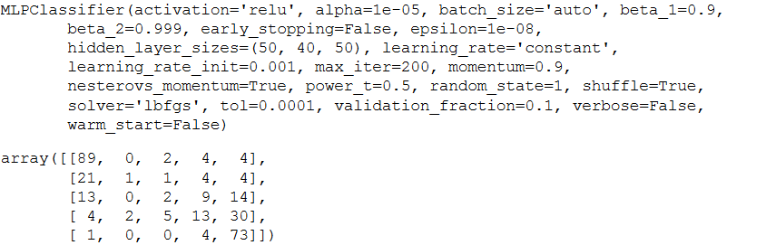

**K-Nearest Neighbors Algorithm:** Satisfaction rating was predicted with respect to other numeric columns in the dataset. After fitting the algorithm, we achieved model accuracy of 40%.

In confusion matrix, the diagonal items represent true-positive values whereas everything else either represents true-negative or false-positive values. This corresponds to error of 60%.

**Parameters and confusion matrix**

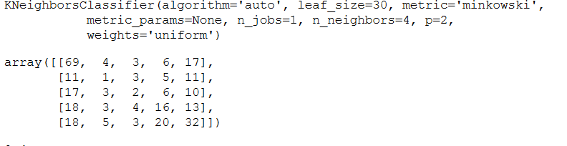

**Comparison of all Classification Algorithms:**

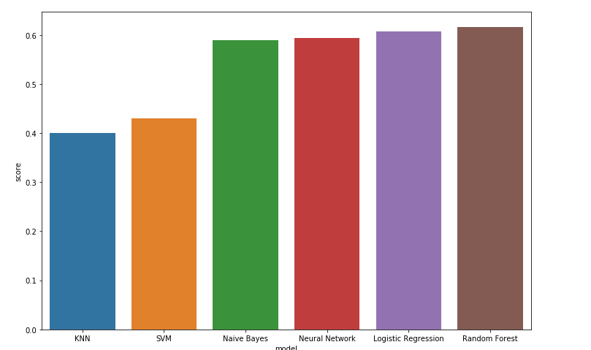

Hence, we found that Random Forest algorithm aligns with the data and proved to be a better classifier for our dataset.

**Parameter Tuning**: We performed Grid search on Neural Network algorithm which yielded us a average precision of 50%, although there were no significant performance improvement was observed.

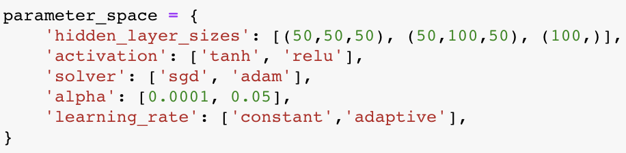

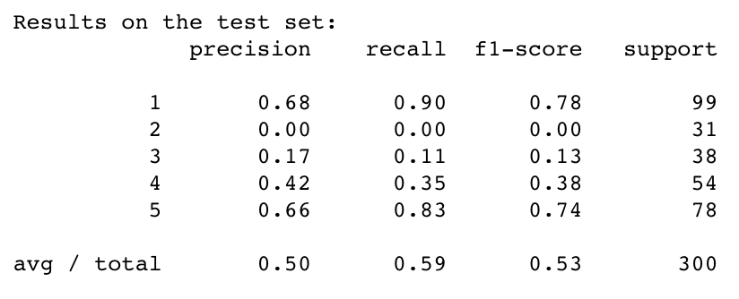

1. **LDA Topic Modeling**

Performed LDA topic modeling on our dataset to look for abstract topics that might occur in the collection of document

LDA without tfidf

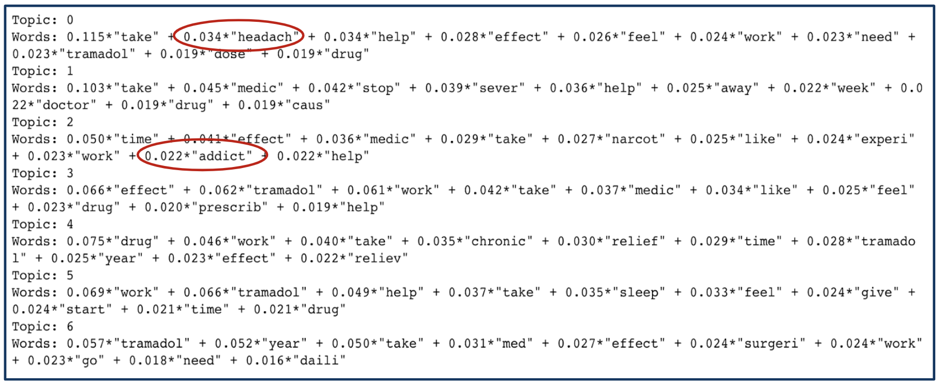

LDA with tfidf

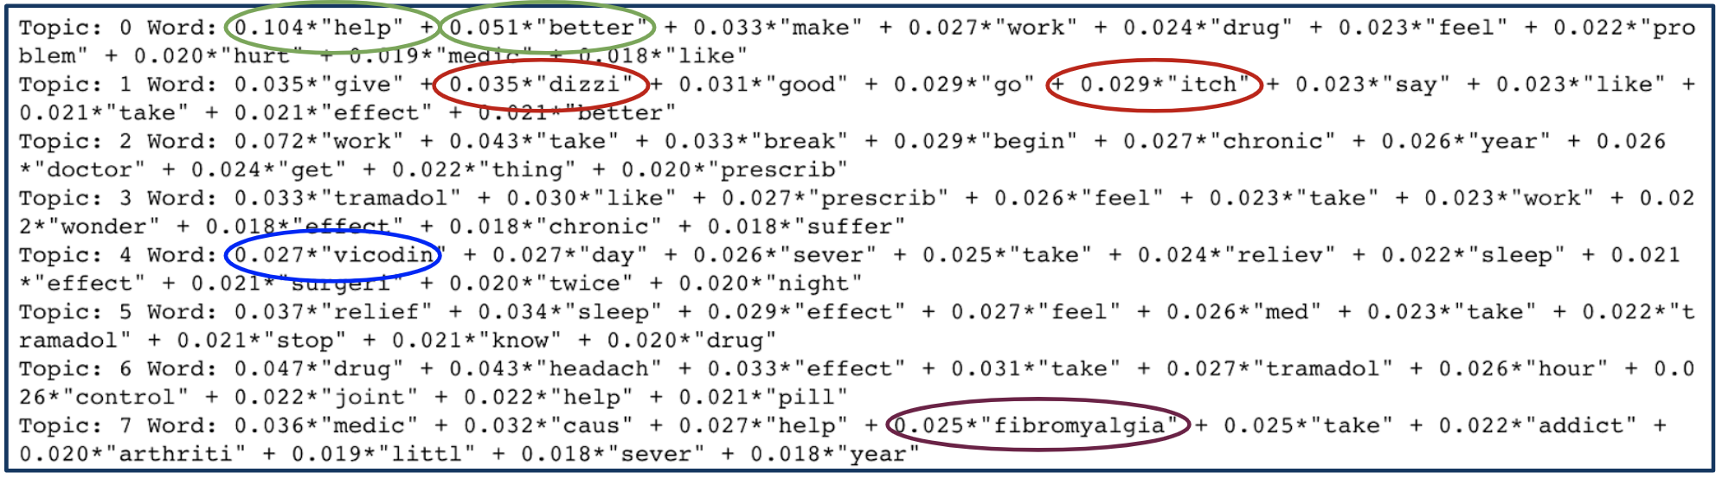

* **1st topic** mentions the positive words, it means it works for a fair amount of customers
* **However, 2nd Topic** shows the side effects like “**Dizziness**” and “**Itching**”
* Also, People who need more potent drugs use “**Vicodin**” instead of “**Tramadol**”
* **Fibromyalgia** is widespread muscle pain in back and shoulder. That one of the reason patients are prescribed Tramadol to **reduce pain**

**6. Sentiment Analysis**

We found that most of the comment were negative and subjective

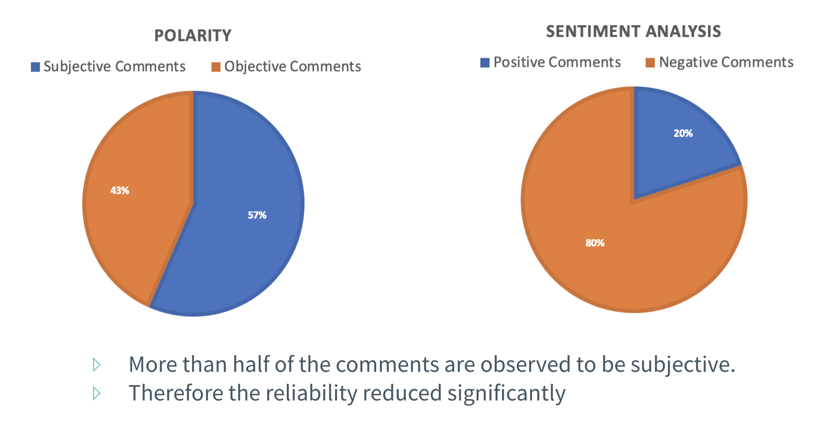

1. **Comparative analysis with other drugs**

Different age groups have a different pattern of side-effects. Just by observing the graph is becomes much clear that the drugs have different side-effects across the age groups. It is also affected by the gender of the patients.

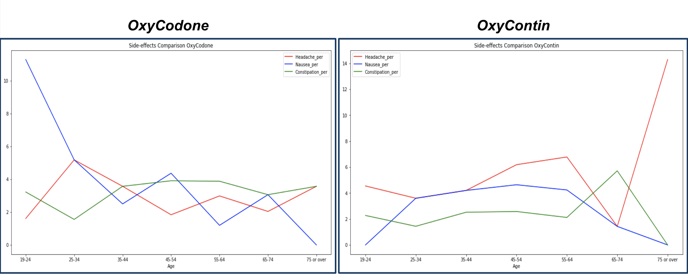

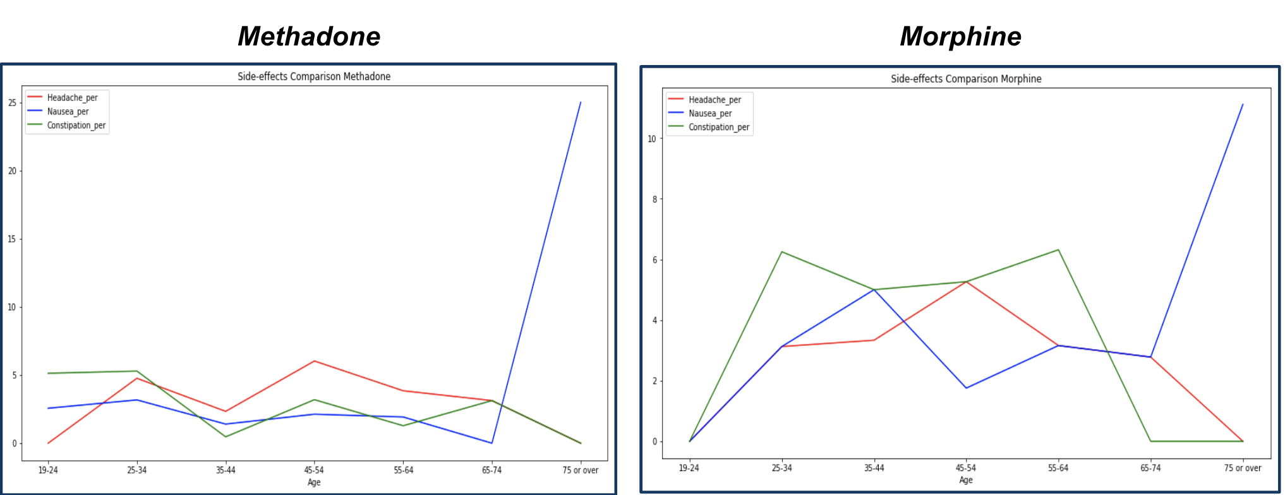

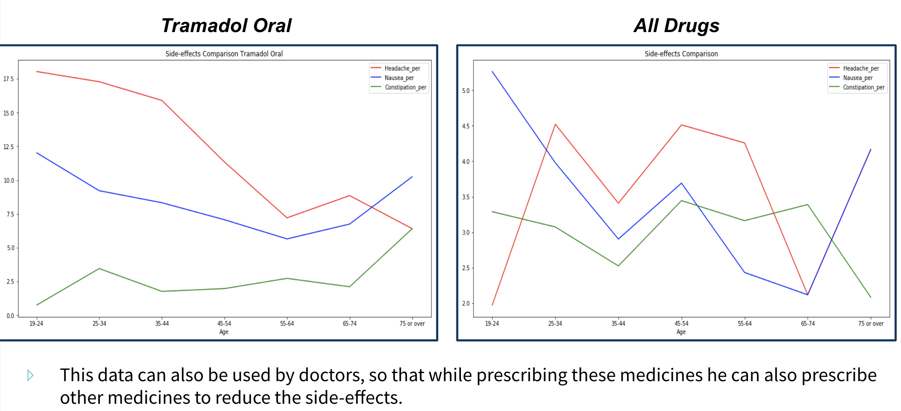

**Conclusion and Future work:**

* WebMD reviews are not the ideal place for drug companies to look for insights since people are inherently **biased** either along a positive side or a negative one.
* However, it is a good source to know the customers **sentiments**, the **drug side-effects** and study **competitor’s** drugs.